Activity 6.1: Writing an algorithm to encode an image
Imagine that you are coding a video game and you want to use this tick sprite:
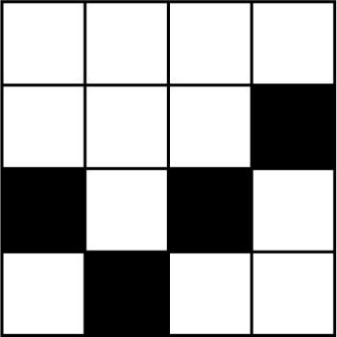
For the game console to store, process and display the tick sprite image, it must be turned into a string of binary code.
- Write an algorithm for turning the image into a string of binary code.

- Use your algorithm to write a string of binary code to represent the image.

